POWER BI – WEEK 7 PROJECT REPORT

Student Performance Data Analysis

1. Objective
The objective of this project is to clean, transform, and prepare the student performance dataset using Microsoft Power BI. The dataset contains student demographic information, preparation details, and scores in Mathematics, Reading, and Writing.

2. Dataset
Dataset Name: StudentsPerformance.csv
Tool Used: Microsoft Power BI
Dataset Size: 1000 student records

3. Data Import
The StudentsPerformance.csv dataset was imported into Power BI using Get Data → Text/CSV. The data was opened in Power Query Editor for inspection and transformation.

4. Data Inspection and Cleaning
The dataset was checked for:
- Missing values
- Duplicate records
- Invalid values
- Incorrect data types
- Inconsistent categorical values
The dataset was cleaned and the column names were standardized for easier analysis.

5. Data Transformation
The categorical attributes were organized as:
- Gender
- Race/Ethnicity
- Parental Education
- Lunch
- Test Preparation Course
The score attributes were maintained as numeric values:
- Math Score
- Reading Score
- Writing Score

6. Calculated Columns

Total Score
A calculated column was created by adding the three subject scores.
Formula:
Total Score = Math Score + Reading Score + Writing Score

Average Score
The average of the three subject scores was calculated.
Formula:
Average Score = Total Score / 3
The Average Score column was stored as a Decimal Number.

Performance Grade
Students were classified based on their average score:
- A → 80 and above
- B → 60–79
- C → 40–59
- F → Below 40

Pass/Fail
Students were classified using the average score:
- Pass → Average Score ≥ 40
- Fail → Average Score < 40

7. Data Preparation
The final dataset contains demographic information, educational background, preparation information, individual subject scores, total score, average score, performance grade, and pass/fail classification.
The three subject score columns were retained separately to keep the dataset clean and avoid incorrect values during transformation.

8. Data Model
The prepared student performance table was loaded into the Power BI data model after completing the required transformations.

9. DAX Measures
The following measures were created for analysis:
Average Math Score
Average Math Score =
AVERAGE('StudentsPerformance'[Math Score])
Average Reading Score
Average Reading Score =
AVERAGE('StudentsPerformance'[Reading Score])
Average Writing Score
Average Writing Score =
AVERAGE('StudentsPerformance'[Writing Score])
Overall Average Score
Overall Average Score =
AVERAGE('StudentsPerformance'[Average Score])
Overall Pass %
Overall Pass % =
DIVIDE(
CALCULATE(
COUNTROWS('StudentsPerformance'),
'StudentsPerformance'[Pass/Fail] = "Pass"
),
COUNTROWS('StudentsPerformance'),
0
)
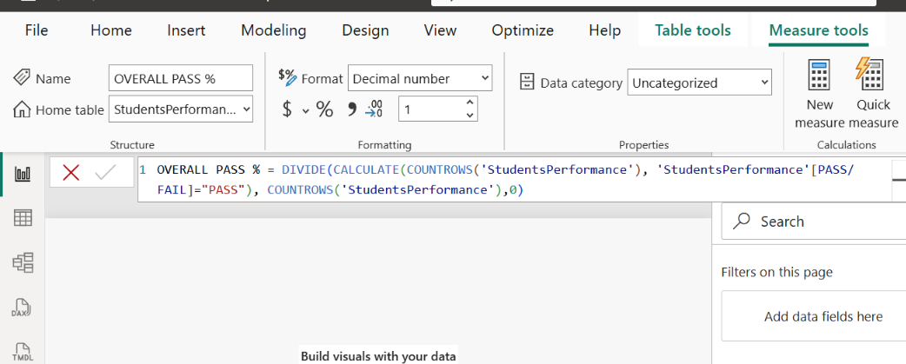

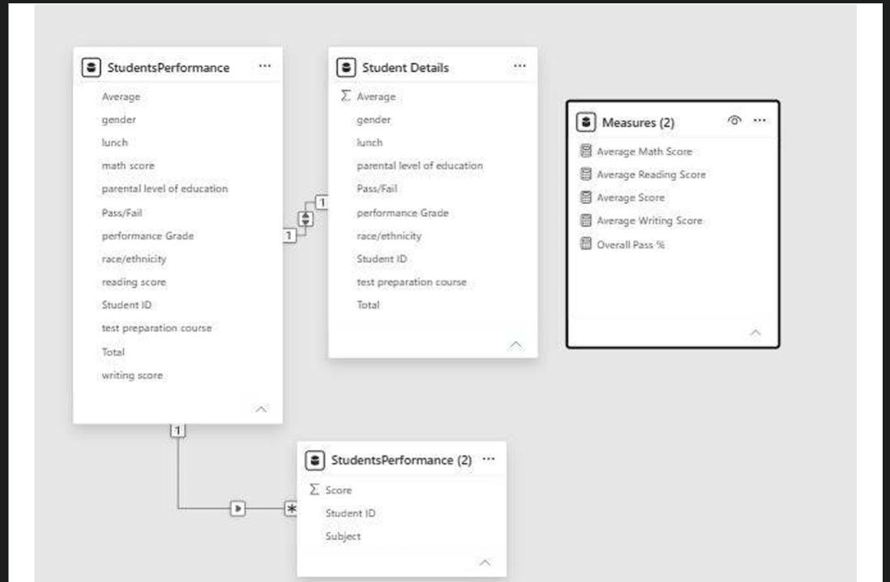

10. Validation
The transformed data was validated to ensure that:
- Score columns contain numeric values.
- Average Score contains decimal values where required.
- Gender and other categorical fields contain appropriate categories.
- Pass/Fail classification is correctly applied.
- Calculated columns and DAX measures return valid results.

11. Week 7 Outcome
The Week 7 task successfully prepared the student performance dataset for visualization and analysis. The cleaned dataset contains calculated performance attributes and analytical measures that can be used to build the Week 8 dashboard.

12. Conclusion
The Week 7 project focused on data preparation, transformation, calculated columns, classification, and DAX measures using Power BI. The prepared dataset provides a structured foundation for creating the student performance dashboard in Week 8.

